Installatie van k8s client op Ubuntu
Installatie en setup met cmd:

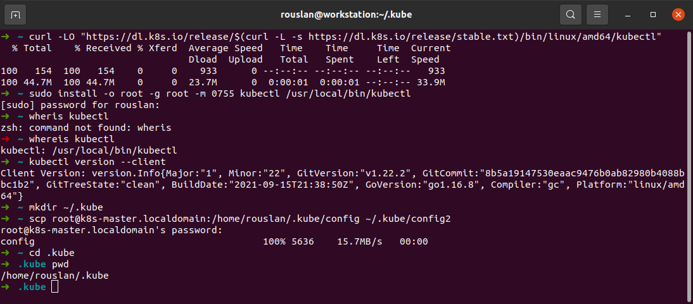
commandos:

curl -LO "https://dl.k8s.io/release/$(curl -L -s https://dl.k8s.io/release/stable.txt)/bin/linux/amd64/kubectl"

sudo install -o root -g root -m 0755 kubectl /usr/local/bin/kubectl

mkdir ~/.kube

scp root@k8s-master.localdomain:/home/rouslan/.kube/config ~/.kube/config2

instellingen in IntelliJ
